**DAILY ONLINE ACTIVITIES SUMMARY**

|  |  |  |  |  |  |  |  |  |
| --- | --- | --- | --- | --- | --- | --- | --- | --- |
| **Date:** | **20/06/2020** | | | | | **Name:** | **Amrutha G** | |
| **Sem & Sec** | **4TH&A** | | | | | **USN:** | **4AL18CS006** | |
| **Online Test Summary** | | | | | | | | |
| **Subject** | | **DATA COMMUNICATION** | | | | | | |
| **Max. Marks** | | **30** | | **Score** | | | **23** | |
| **Certification Course Summary** | | | | | | | | |
| **Course** | **Introduction of information on hacking** | | | | | | | |
| **Certificate Provider** | | | **GREAT LEARNING** | | **Duration** | | | **6 HOURS** |
| **Coding Challenges** | | | | | | | | |
| **Problem Statement 1: Write a C Program to rotate a square matrix by 90 degree either clockwise or anticlockwise** | | | | | | | | |
| **Status: executed** | | | | | | | | |
| **Uploaded the report in Github** | | | | | **YES** | | | |
| **If yes Repository name** | | | | | **https://github.com/AMRUTHAGANESH/lockdown-codings**  **https://github.com/AMRUTHAGANESH/lockdown-certification_course** | | | |
| **Uploaded the report in slack** | | | | | **YES** | | | |

**Online Test Summary:** 18CS46(D.C) test was conducted on 20/06/2020.There were 30 questions (MCQ) with each question carrying 1 marks.The portion for the I.A. was from 3rd and 4th module

Score: 23/30

Snapshot:

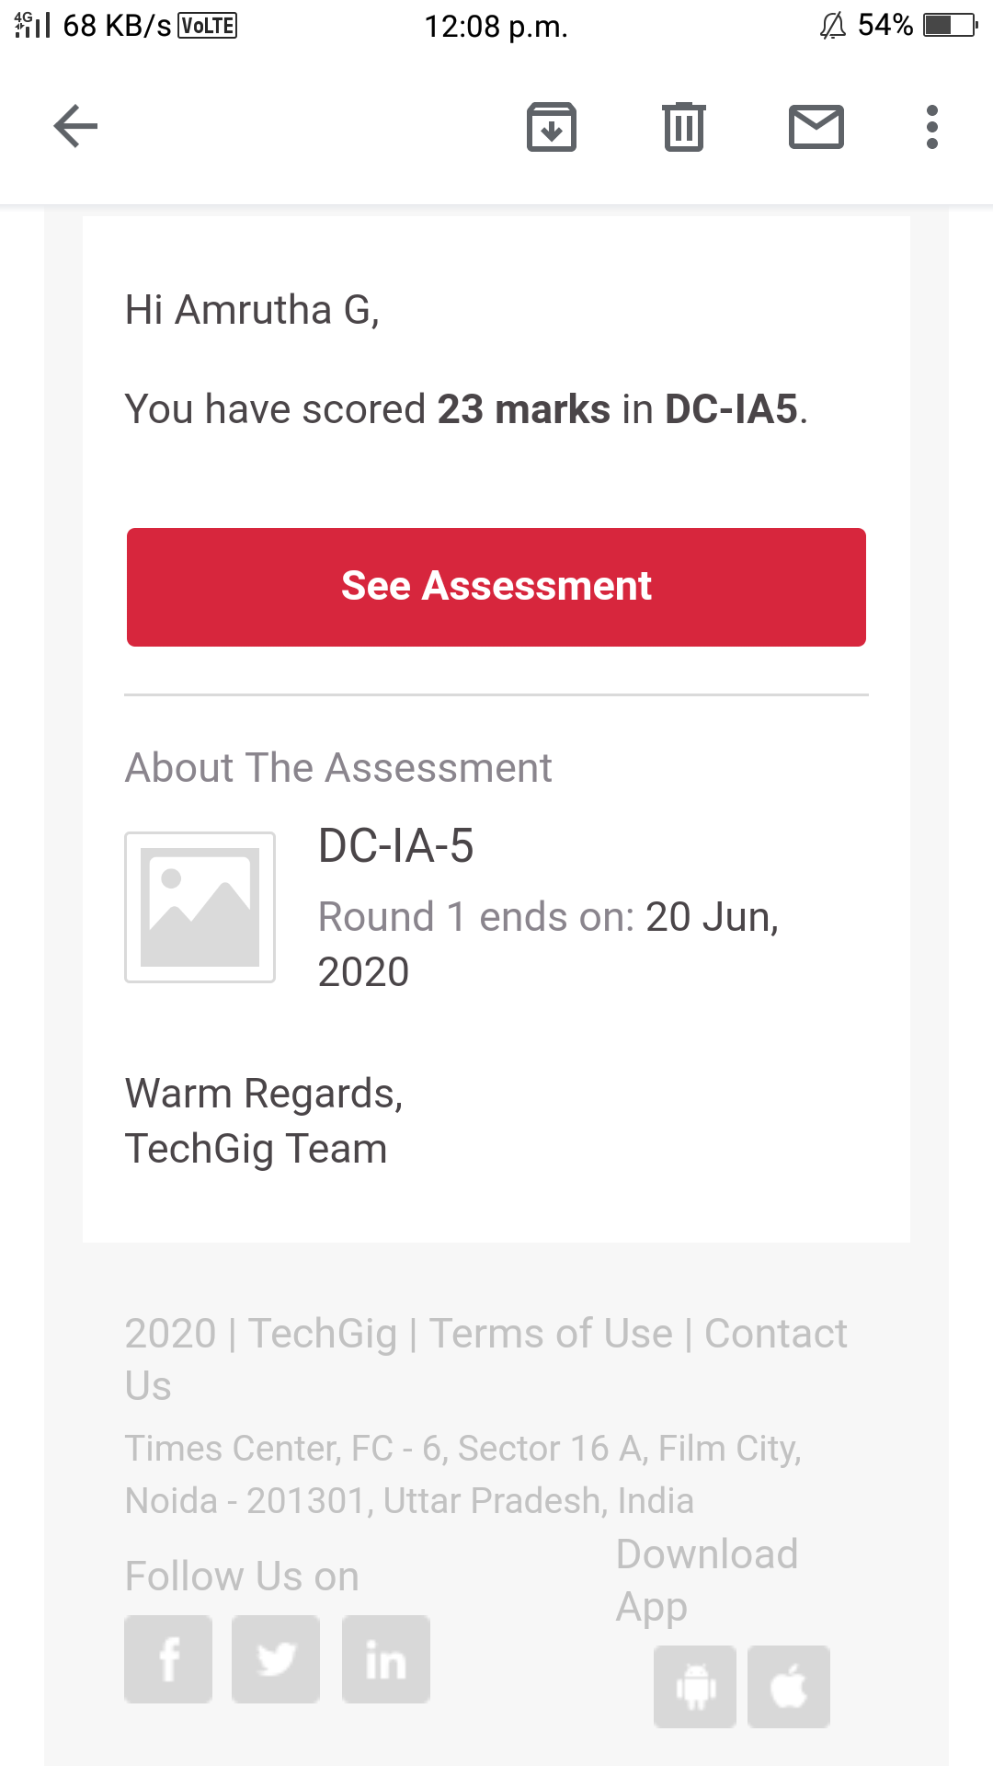

**Online Certification course:**

Name of the course : Introduction of information hacking

Duration: 6 hours

Certificate provider: great learning

Today I have started a new course .The duration of the course is 6 hours.Today I have successfully completed

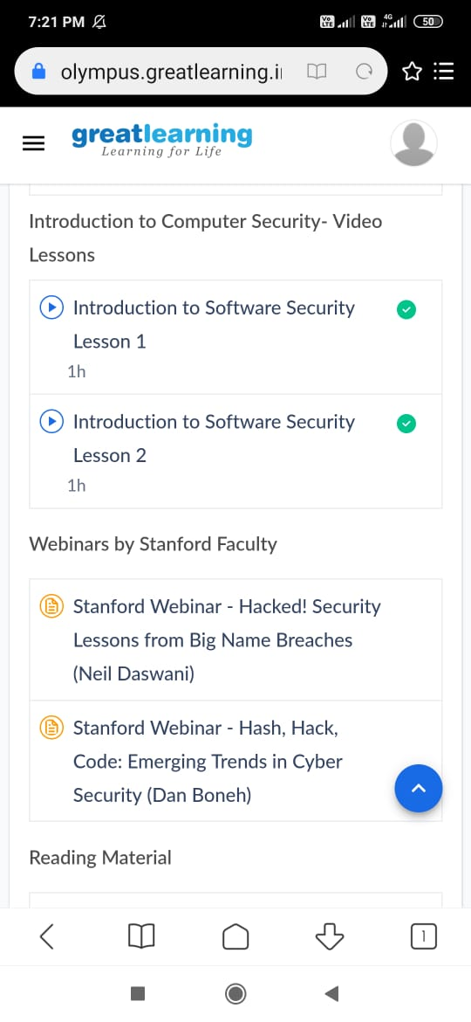

Online Coding summary:

1.  **Write a C Program to rotate a square matrix by 90 degree either clockwise or anticlockwise**

